Wafer Production Line - Optimization

# TPK4186 - Advanced Tools for Performance Engineering Assingment 3: Wafer Production Line

## Created by: Christian G Kartveit & Skjalg Nysaeter

# 2.3 Optimization

# Task 5.

## Simulation with Worst Case

## This is an example of runtime with the worst case solution. One batch is loaded into the simulation, and the next one is not loaded until the first one is finished. This is repeated until all 1000 wafers is produced. The batch sizes is random from 20 to 50 wafers per batch, and therefore some variation in time between each run. The total runtime is: 19698.0 minutes for this simulation.

## Simulation with reduced loadtime between batches

Now we will try to reduce the loading time between the batches. We will simulate 3 simulations, with batch sizes of 20, 50 and random batch size. The graphs below will show the loading times, and the finish time for all 1000 Wafers. The loading time between each batch is increased with a constant number, and the loading time between each batch is the same as the number of simulations. The loading time between each batch is increased from 1 to 300 minutes.

Batchsize 20: The optimal solution is with total time: 5811.0 and loading time between batches 112 minutes.Batchsize 50: The optimal solution is with total time: 5879.0 and loading time between batches 264 minutes.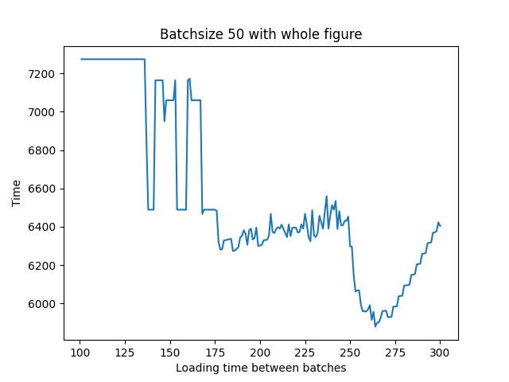

Observe that the optimal loading time between each task from batchsize 20 and batchsize 50 is proportional to the batchsize.

Batchsize random: The optimal solution is with total time: 5909.0 and loading time between batches 186 minutes. NOTE: With random batchsize, the optimal solution is likely to change from run to run.

# Task 6.

## Simulation with changed ordering heuristic

The previous results show the optimal time with 20, 50 and random batch sizes with standard task prioritization, with Unit 1 : [1, 3, 6, 9], Unit 2 : [2, 5, 7] and Unit 3 : [4, 8]. Now we will change the order tasks are prioritized. It is 288 possible permutations of the tasks, and we will simulate batchsize 20, since that gave us the best results. That means 300 simulations, with different load time, times 288 permutations. The total number of simulations is 86 400 per batch size. The results are shown below.

The best solution for batchsize 20 is with total time: 5774.0 and loading time between batches 111 minutes. and the best ordering heuristic is: Unit 1 : [9, 3, 1, 6] Unit 2: [5, 7, 2] Unit 3: [4, 8]

This resulted in a time that is 37 minutes better.

# Task 7.

## Simulation with different loading time, ordering heuristic and batchsizes

Now we will simulate the optimal time with different batchsize. We will run the most optimal permutation found in the previous task. We will only show the optimal time for each batchsize.

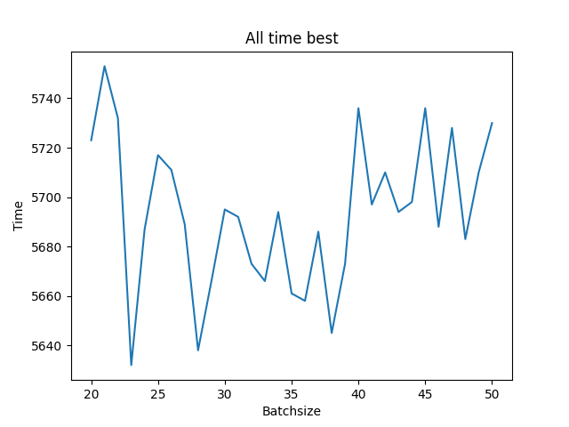

The all time best solution is with total time: 5632.0 and loading time between batches 81 minutes. The optimal batch size is then 23 wafers per batch

The optimization process had to be split manually up in different sections because of the heavy load of doing all the simulation loops. We ran the simulations using a good computer through a Docker container, using the Dockerfile.